ER & EER diagram

**ER DIAGRAM:**

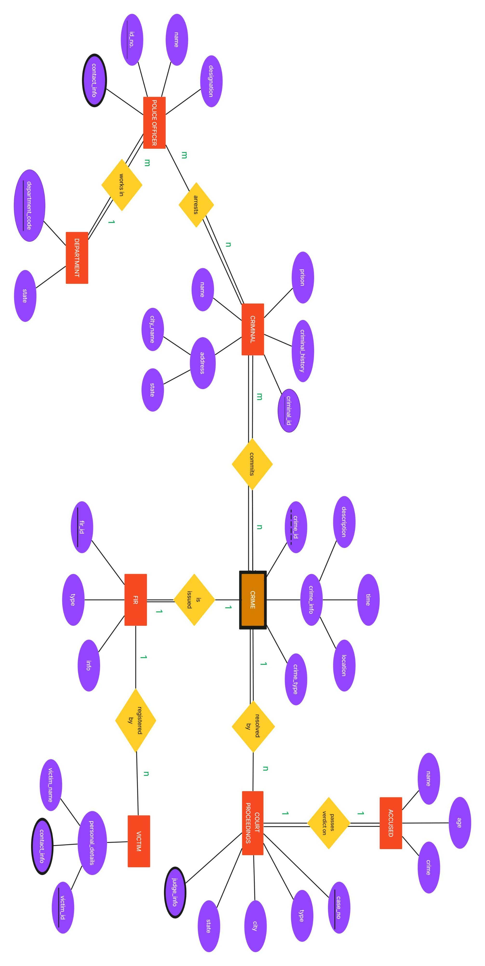

**EER DIAGRAM:**

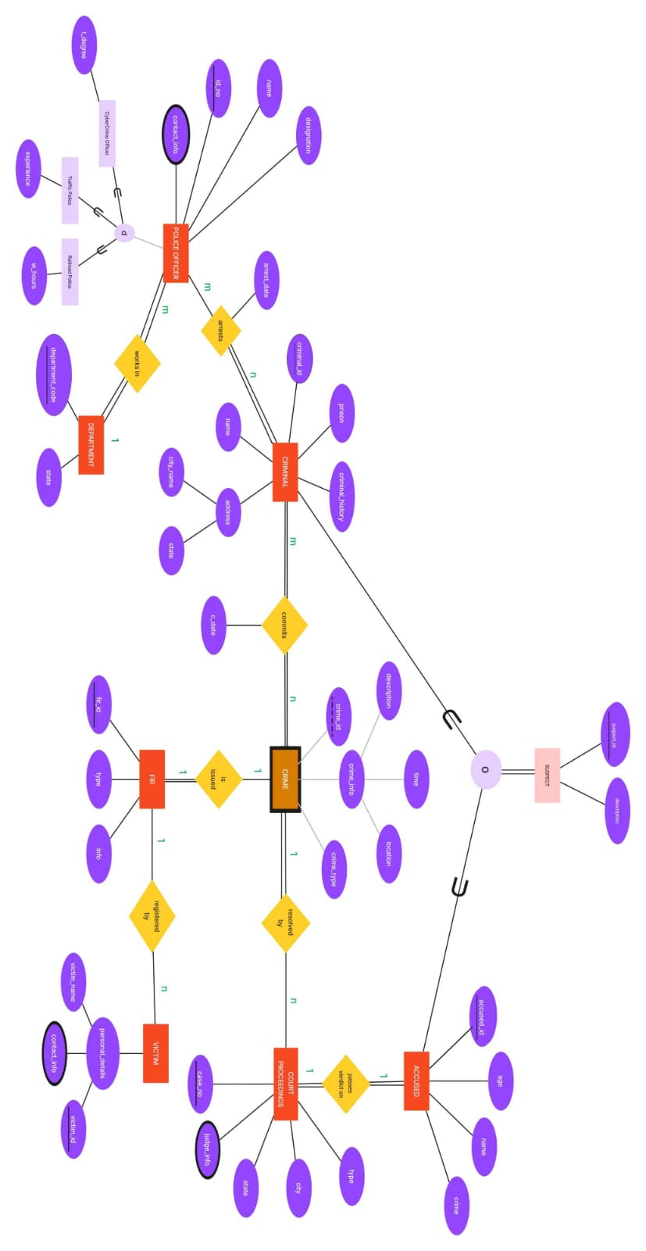

Conclusion: LO1 mapped